Curriculam Vitae
Objective
Seeking position to utilize my skills and abilities that offer professional growth while being resourceful, innovative and flexible and prove myself worthy in the development of the organization.

Educational Qualification

Qualification | Institution | University | Year of passing
PhD | Department of Communication and Media Studies | Bharathiar University | Pursuing
MPhil | Department of Communication and Media Studies | Bharathiar University | 2022
MCJ | Department of Journalism and Communication | University of Calicut | 2013
BA Mass Communication | Pazhassiraja College, Pulpally | Calicut University | 2011
Plus Two | Christ PU College, Bangalore | Department of Pre-Education, Bangalore | 2008
SSLC | St. Joseph’s HSS, Kodenchery, Kozhikode | Board of Public Examination, Kerala | 2005

Professional qualification
- 2020- National Eligibility Test (NET)
- 2020 -Maulana Azad National Fellowship for Minority Students (MANF)
- 2018-Kerala State Eligibility Test (SET)
- 2013-British Council Aptis Forward thinking English Test

Computer Proficiency
- Operating Systems-Ubuntu and Windows
- Diploma in Adobe Premier, Photoshop and PageMaker
- Adobe Audition
- FCP

Ms. Lincy Joseph
MCJ,MPhil, NET, SET
Vellamchalil (H)
Kodenchery (PO)
Kozhikode, Kerala
Pin: 673580
Email: lincyvjoseph@gmail.com
Mobile: +91 9447480041
+91 8848267497

Personal Data

DOB : 30/12/1989
Age : 35 years
Sex : Female
Nationality : Indian
Religion : Christian
Marital Status : Single

Languages Known

English
Malayalam
Tamil
Hindi

Strengths
- Good inter personal communication skills.
- Smart worker and good team player.
- Easley understands people’s emotions and feelings
- Ability to adapt to changes.

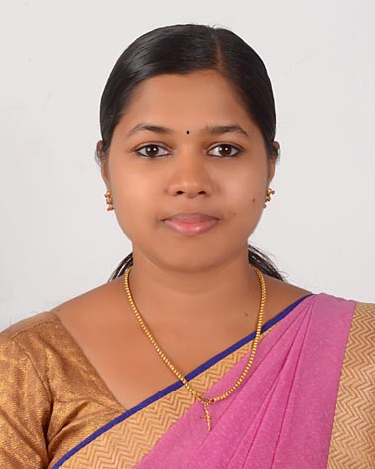

Paper Publication
Sl. No | Title | Publication | ISSN | Volume/ Issue | Edition
 | A study on the Effectiveness of Radio Jingles among Youth | International Journal of Communication and Media Studies | 2250-0014 | 11/1 | April 2021

Paper Presentation
No | Title of the paper | Conference/ seminar
 | Consumption and Influence of Mass Media among Tribes in Wayanad | Three- day Mult-disciplinary National Conference on “Vision for India @2047
 | A critical Analysis of Social Media in Creating a New Subculture Among Tribal Youth in Wayanad District | International E- Conference on "Age of Digitisation: Redefining Media, Language, Literature, Culture and Development”
 | Impact of Social Media on Young generation | International Conference on Media & Gender: Perspective, Issues and Challenges
 | The Role of Media in Creating Social Awareness about the Female Hygiene Practices | Two day South Asian Conference on “Menstrual Health and Hygiene – Menstrual Waste Management”
 | Health Communication and Media | South Asian Conference on “Healthcare at the Crossroads- Transforming Healthcare in India @ 75”
 | Bridging the Digital Divide In Viksit Bharat @2047: Empowering Vulnerable Groups in Wayanad District, Kerala | National Conference on Viksit Bharat @ 2047: The Forward – Challenges and Prospects by the School of Mass Communication, KIIT University sponsored by the Indian Council of Social Science Research (ICSSR), Ministry of Education, Government of India
 | Empowering Tribal Communities in Wayanad through Communication Technology:  Innovative Approaches to Education for Vision Viksit Bharat@2047 | National Seminar on Innovative Approaches to Social Impact in Vision Viksit Bharat@2047:  Leveraging Emerging Technologies for Sustainable Development Sponsored by  ICSSR (Indian Council of Social Science Research),

Teaching Experience: Eight years and Seven months

Sl No | Name of College/Institution | Designation | Duration
 | Pazhassiraja College, Pulpally | Assistant Professor in Journalism and Mass Communication | Two Years (Currently working here from June 2022)
 | Pazhassiraja College, Pulpally | Assistant Professor on Contract in Mass Communication and Journalism | Five Months (June 2019 - October 2019)
 | Little Flower Institute of Social Sciences And Health (LISSAH), Kaithapoyil | Assistant Professor in Mass Communication and Journalism | Three Years (August 2016 to April 2019)
 | A V Abdurahiman Haji Arts and Science College, Payyoli Angadi | Assistant Professor in Mass Communication and Journalism | Two Years (June 2014 to May 2016)
 | Exter College of Sciences and Commerce, Manjeri | Assistant Professor in Mass Communication and Journalism | One Year (August 2013 to June 2014)

Reference
Dr. P E Thomas Mr. Abdul Bari AB
Former Head Principal I/c
Department of Communication and Media Studies Pazhassiraja College
Bharathiar University Pulpally
Coimabatore Mob: +91 9747670210
Mob: +91 9842084804

Declaration
I, here by declare that the information given above are true to the best of my knowledge and belief.

Kodenchery 
24/02/2025 Lincy Joseph

